LIGTAS SAKAY MOBILE APPLICATION

Project Documentation Submitted

To the Faculty of School of

Computer Science and Information Technology

Of

Asia Pacific College

In Partial Fulfillment of the Requirements for the Subject

SYSADD1

By

Dizon, Dan Patrick R.

Maraya, Lorina P.

Pilares, Dwight Stephen Paolo C.

Pintado, Vic Arthur G.

To promote

Ligtas Patrol Group

Table of Contents:

[-Project Authors](http://projects2.apc.edu.ph/wiki/index.php/Project_-_Ligtas_Sakay_Mobile_Application#Project_Authors)

[- Professor](http://projects2.apc.edu.ph/wiki/index.php/Project_-_Ligtas_Sakay_Mobile_Application#Professor)

[- Adviser/Project Consultant](http://projects2.apc.edu.ph/wiki/index.php/Project_-_Ligtas_Sakay_Mobile_Application#Adviser.2FProject_Consultant)

[- Project Team](http://projects2.apc.edu.ph/wiki/index.php/Project_-_Ligtas_Sakay_Mobile_Application#Project_Team)

[- General Objectives](http://projects2.apc.edu.ph/wiki/index.php/Project_-_Ligtas_Sakay_Mobile_Application#General_Objectives)

[- Specific Objectives](http://projects2.apc.edu.ph/wiki/index.php/Project_-_Ligtas_Sakay_Mobile_Application#Specific_Objectives)

[- Target Audience](http://projects2.apc.edu.ph/wiki/index.php/Project_-_Ligtas_Sakay_Mobile_Application#Target_Audience)

[- Cite Related Architecture](http://projects2.apc.edu.ph/wiki/index.php/Project_-_Ligtas_Sakay_Mobile_Application#Cite_Related_Architecture)

[- Project Description](http://projects2.apc.edu.ph/wiki/index.php/Project_-_Ligtas_Sakay_Mobile_Application#Project_Description)

[- Glossary](http://projects2.apc.edu.ph/wiki/index.php/Project_-_Ligtas_Sakay_Mobile_Application#Glossary)

[- Project Plan and/or Network Project Plan](http://projects2.apc.edu.ph/wiki/index.php/Project_-_Ligtas_Sakay_Mobile_Application#Project_Plan_and.2For_Network_Project_Plan)

- SYSADD1 (Proposed)

[-Event Table](http://projects2.apc.edu.ph/wiki/index.php/Project_-_Ligtas_Sakay_Mobile_Application#Event_Table) -Package Diagram

[-Use Case Diagram](http://projects2.apc.edu.ph/wiki/index.php/Project_-_Ligtas_Sakay_Mobile_Application#Use_Case_Diagram) -State Machine Diagram

[-Use Case Full Description](http://projects2.apc.edu.ph/wiki/index.php/Project_-_Ligtas_Sakay_Mobile_Application#Use_Case_Full_Description) -Timing Diagram

[-Context Flow Diagrams](http://projects2.apc.edu.ph/wiki/index.php/Project_-_Ligtas_Sakay_Mobile_Application#Context_Flow_Diagrams) [-Activity Diagram](http://projects2.apc.edu.ph/wiki/index.php/Project_-_Ligtas_Sakay_Mobile_Application#Activity_Diagram)

[-Data Flow Diagrams](http://projects2.apc.edu.ph/wiki/index.php/Project_-_Ligtas_Sakay_Mobile_Application#Data_Flow_Diagrams) [-Data Dictionary](http://projects2.apc.edu.ph/wiki/index.php/Project_-_Ligtas_Sakay_Mobile_Application#Data_Dictionary)

[-Entity Relationship Diagrams](http://projects2.apc.edu.ph/wiki/index.php/Project_-_Ligtas_Sakay_Mobile_Application#Entity_Relationship_Diagrams) [-Soft copies of Signed Status Reports](http://projects2.apc.edu.ph/wiki/index.php/Project_-_Ligtas_Sakay_Mobile_Application#Soft_copies_of_Signed_Status_Reports)

-Sequence Diagram [-Gantt Chart/WBS/Activity List](http://projects2.apc.edu.ph/wiki/index.php/Project_-_Ligtas_Sakay_Mobile_Application#Gantt_Chart.2FWBS.2FActivity_List)

-Class Diagram

-Object Diagram

-Component Diagram

-Composite Diagram

-Interaction Diagram

Professor – Mr. Manuel Sanchez

Adviser – Mr. Ernesto Boydon

Project Team – Dwight Stephen Paolo C. Pilares

Dan Patrick R. Dizon

Lorina P. Maraya

Vic Arthur G. Pintado

General Objectives:

To make a system that will give benefits to commuters and to provide security whenever they travel.

Specific Objectives:

* To encourage passengers to report abusive PUV Drivers
* To encourage passengers to report violations they have encountered
* To motivate commuters to take a part in making travel experience safe and efficient.

Target Audience:

* Commuters

Project Description:

* Ligtas Sakay Mobile Application is a safety commuting application which can help passengers to immediately report abusive PUV Drivers they may encounter. Summary features of the application includes QR Code Scanner - Scan QR Code of PUV and automatically shows information of the vehicle as well as driver's information and send it to assigned contact, Track users' location, Report Button and Danger Button.

Glossary:

* Mobile Application - a type of application software designed to run on a mobile device.
* Commuters - a person who travels some distance to work on a regular basis.
* System Admin - a person who is responsible of the System Operation
* PUV - Public Utility Vehicle

Event Table:

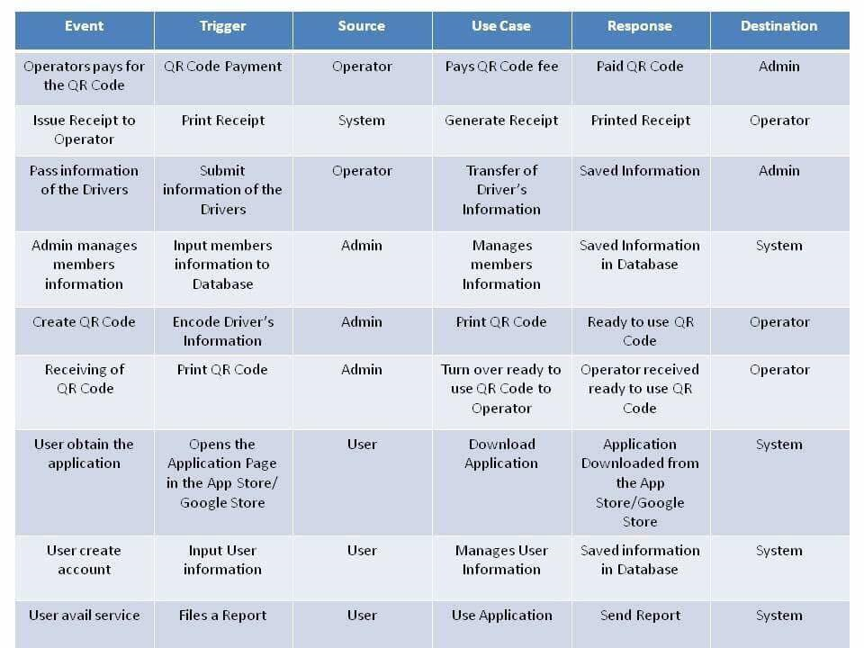

Use Case Diagram:

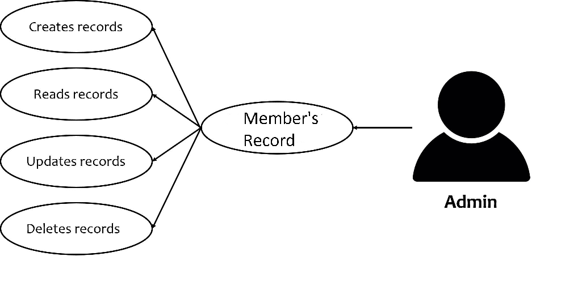

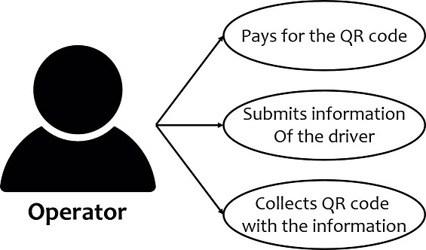

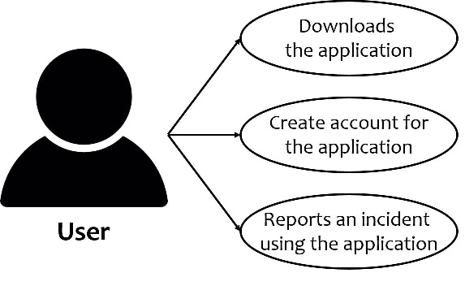

Context Flow Diagram:

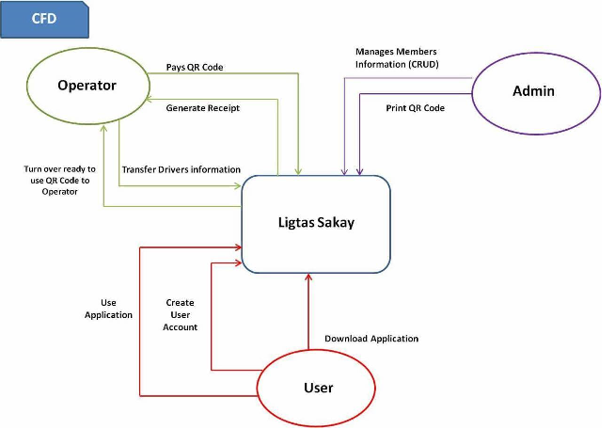

Data Flow Diagram:

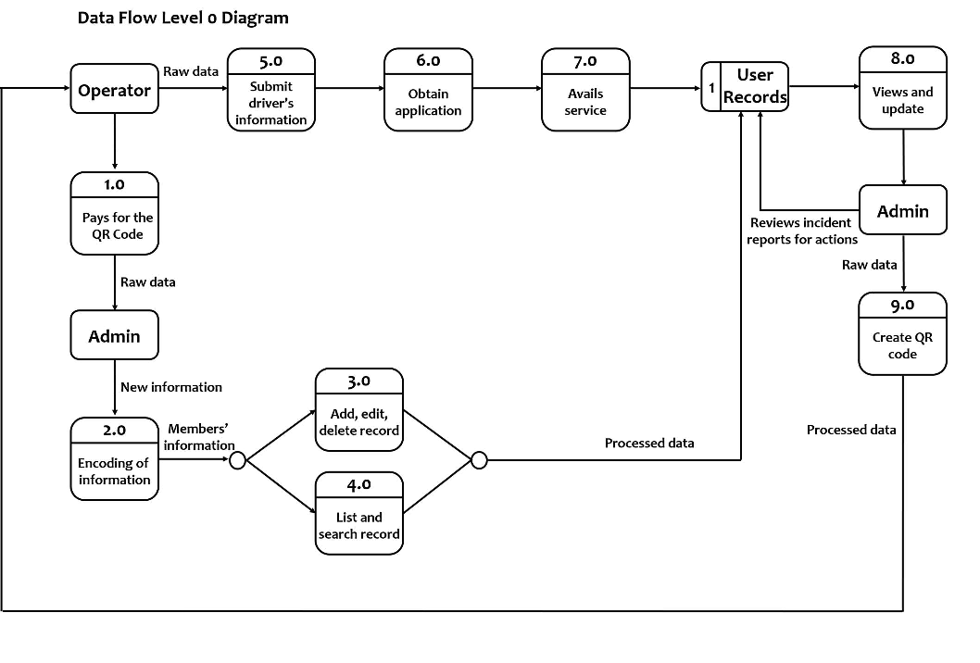

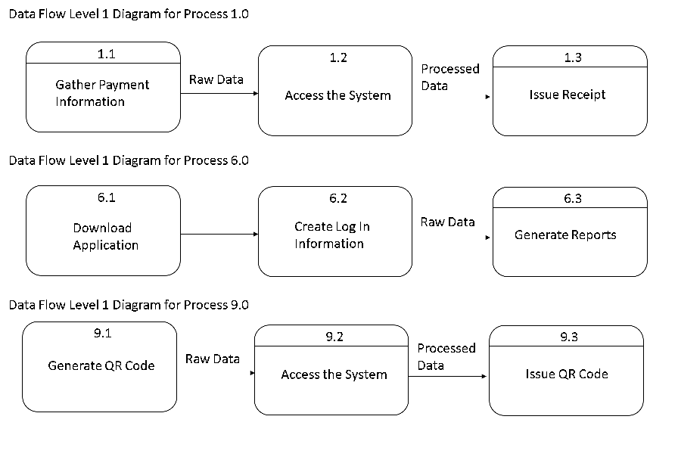

Sequence Diagram:

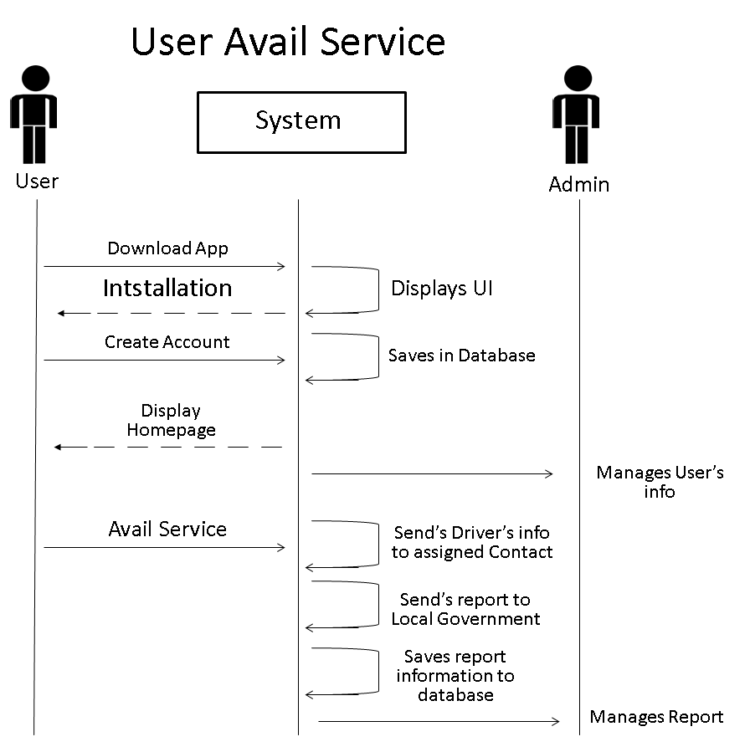

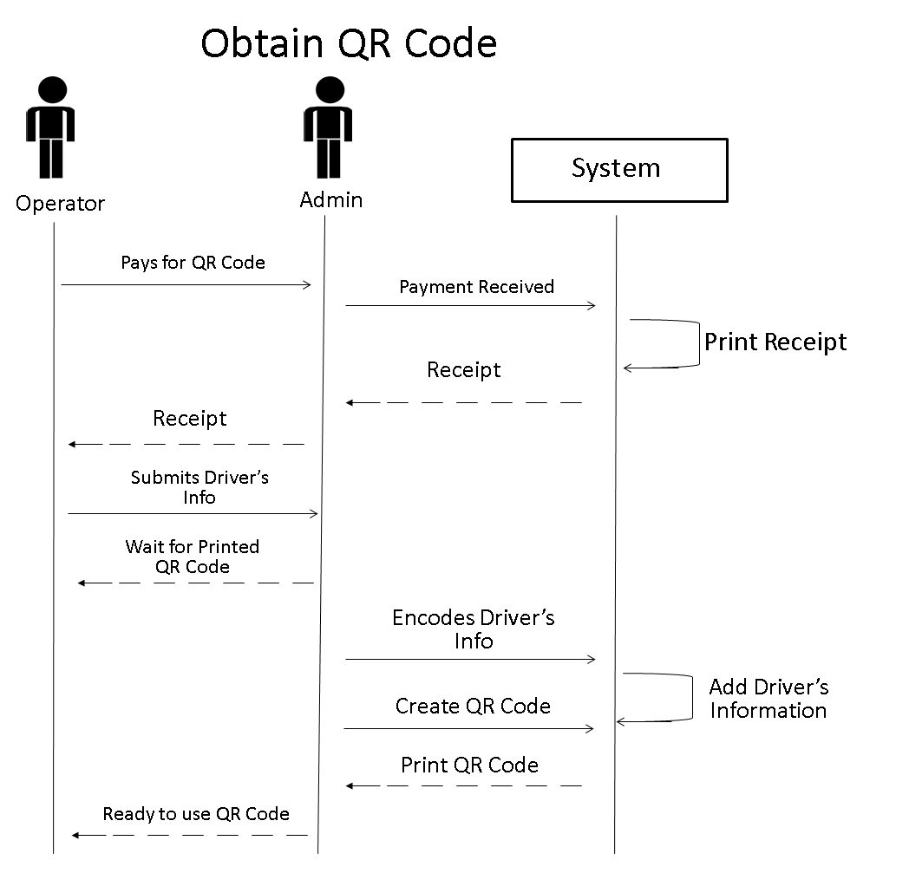

Class Diagram:

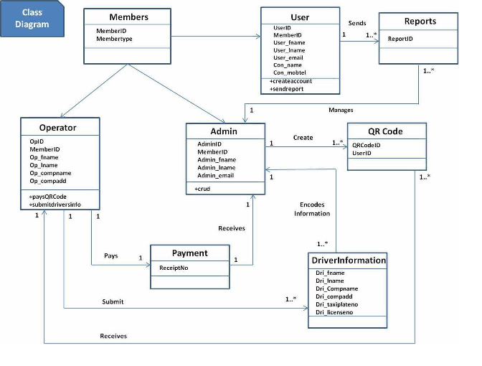

Object Diagram:

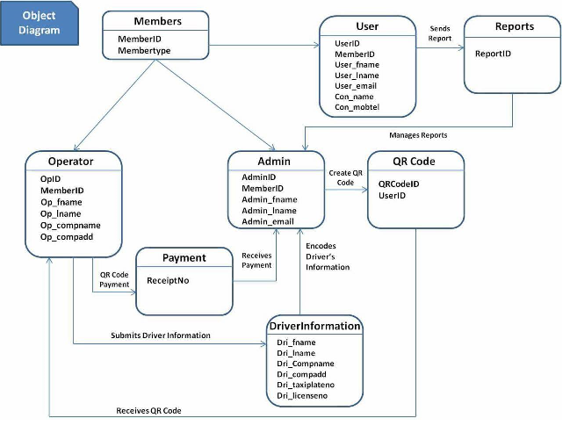

Component Diagram:

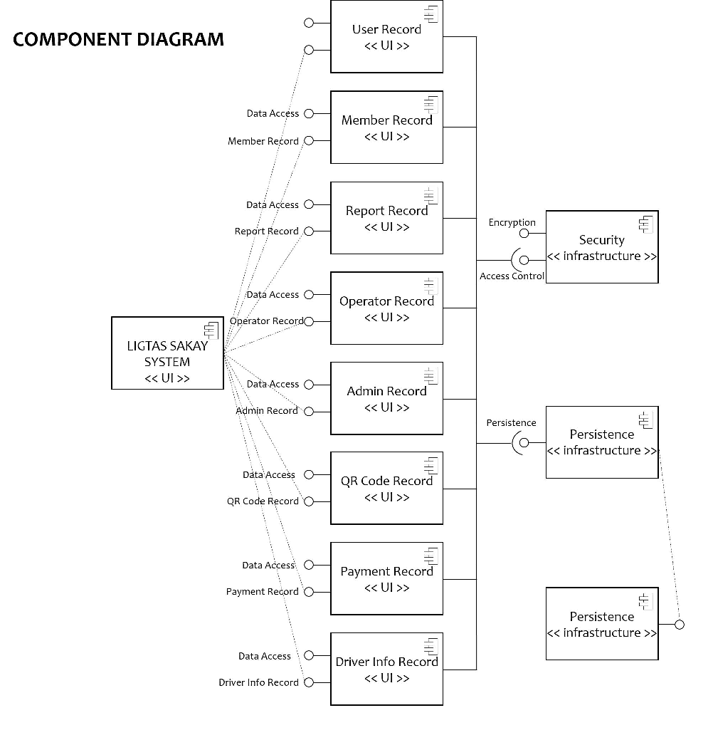

Composite Diagram:

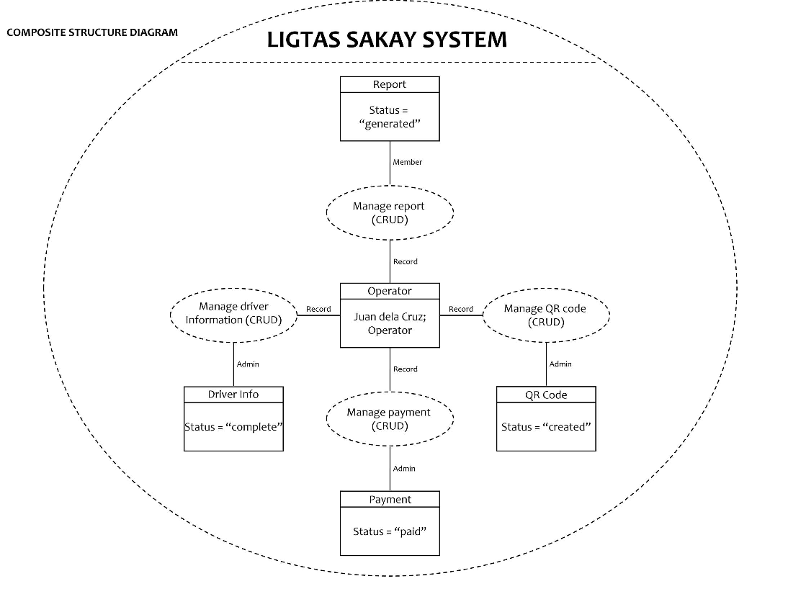

Interaction Diagram:

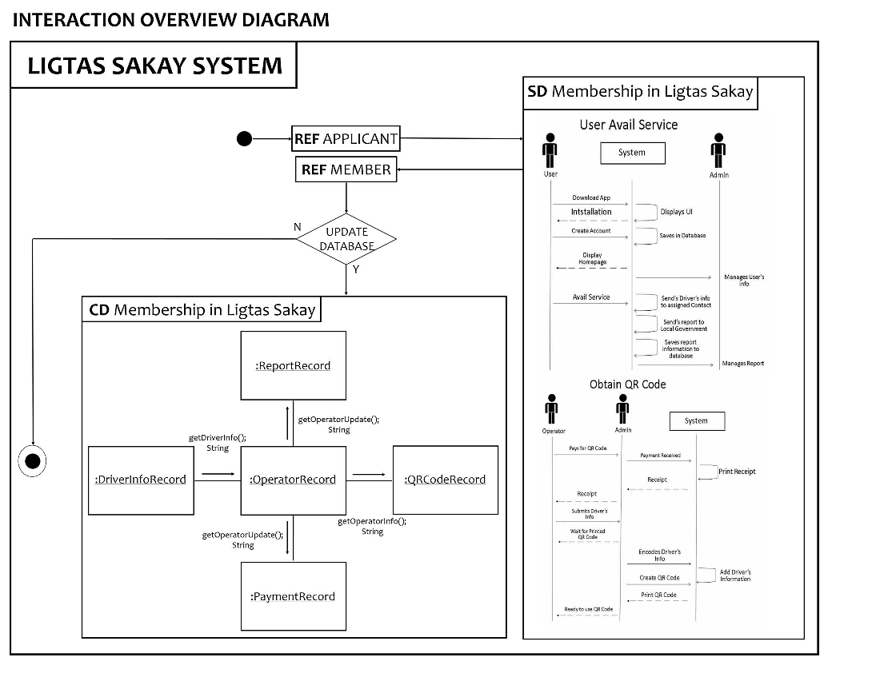

Package Diagram:

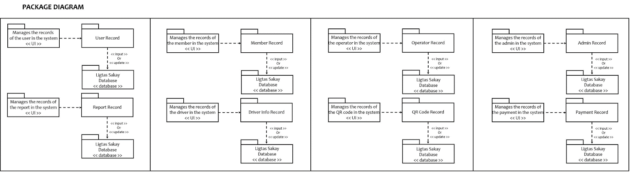

State Machine Diagram:

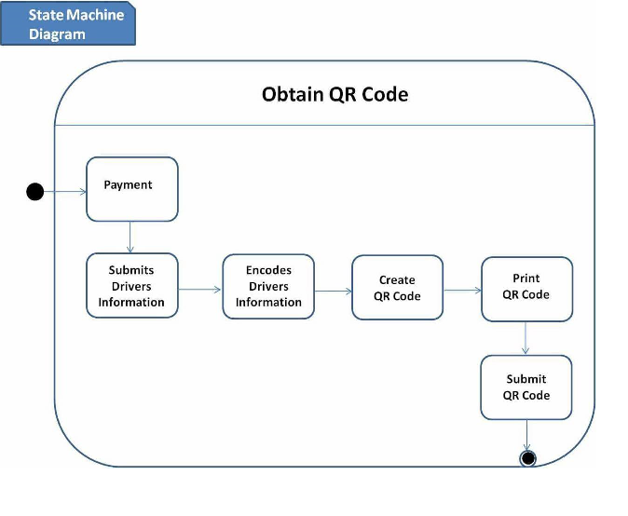

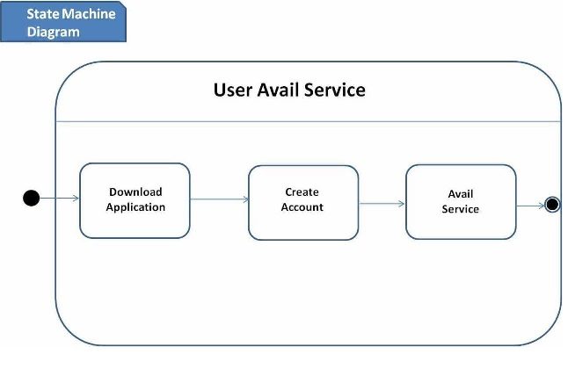

Timing Diagram:

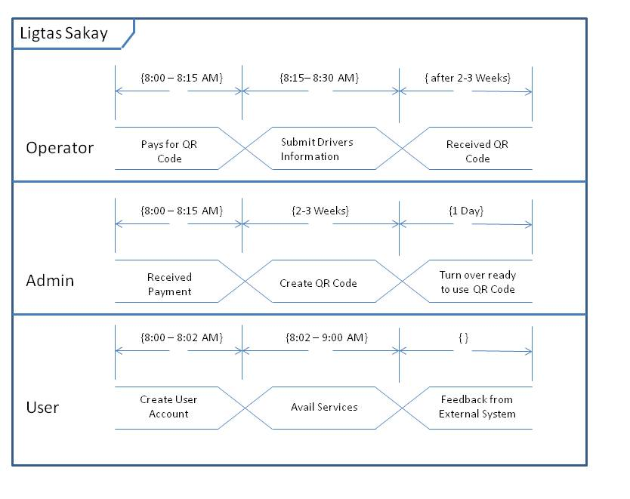

Entity Relationship Diagram:

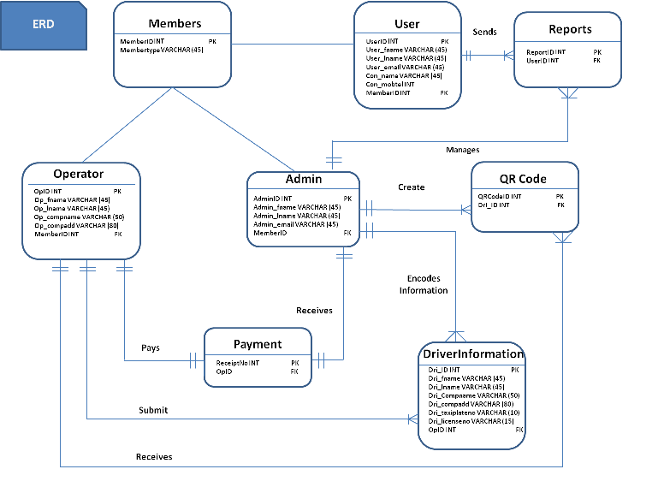

Activity Diagram:

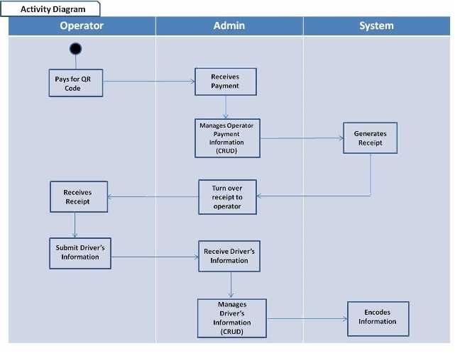

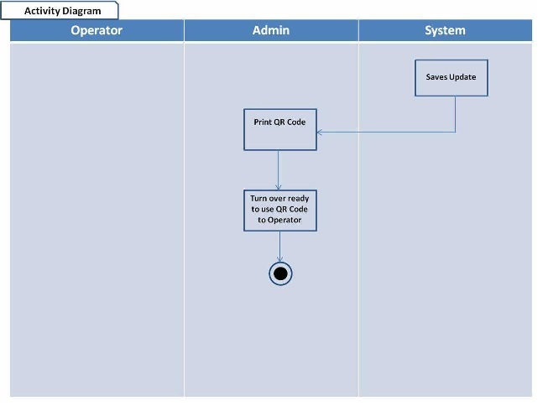

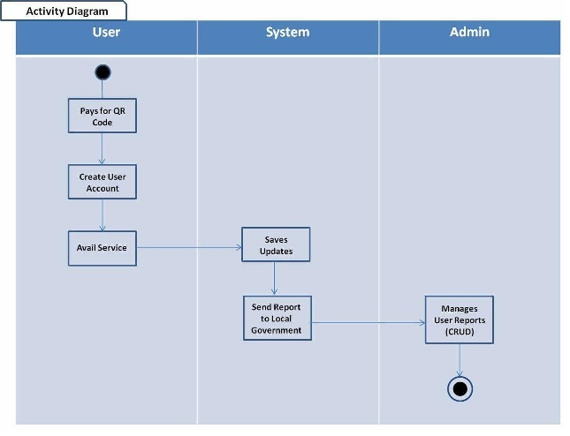

Data Dictionary:

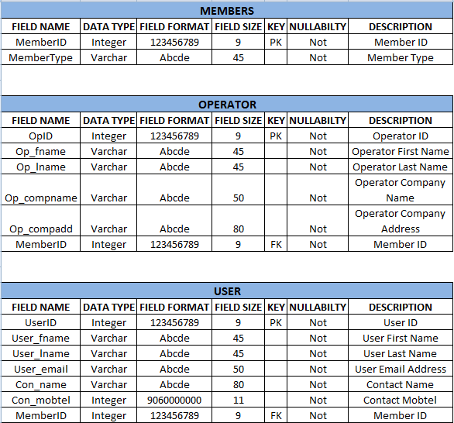

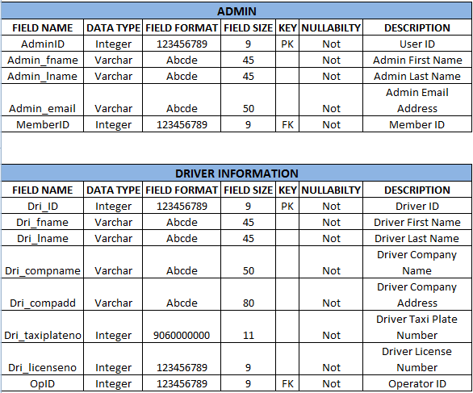

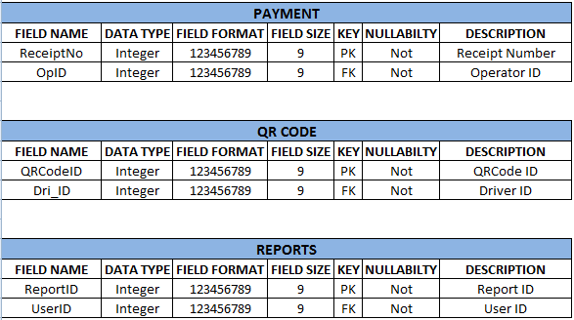

Gantt Chart/WBS/Activity List

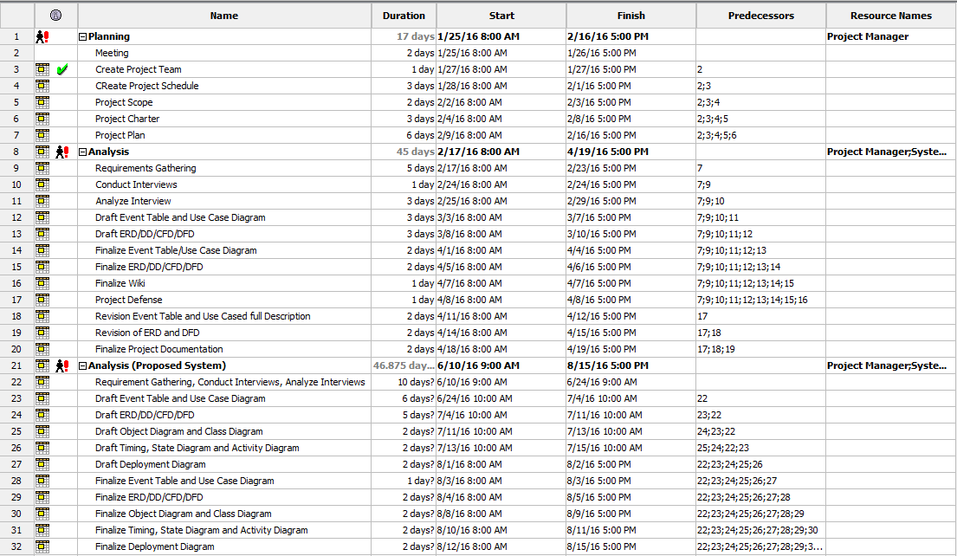

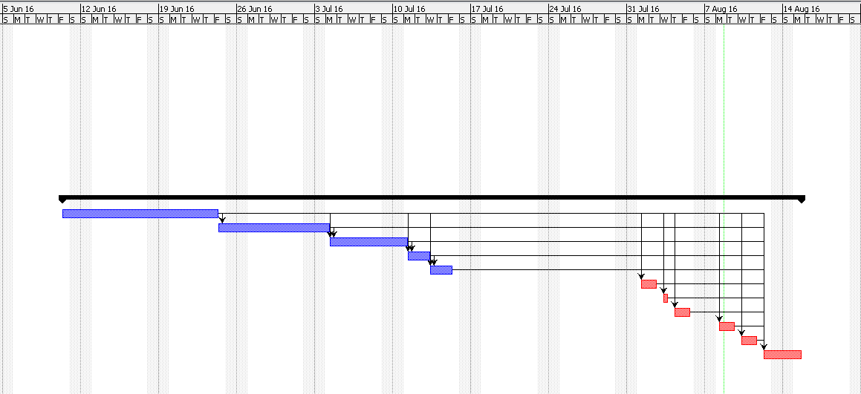

WBS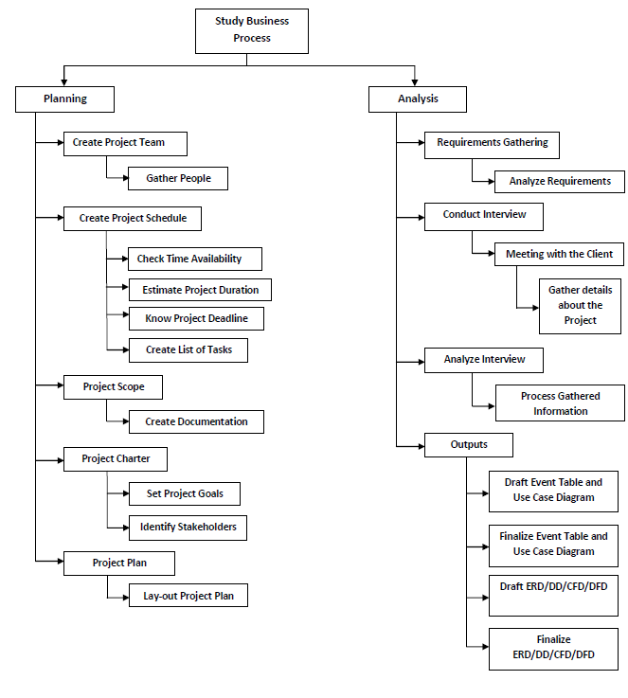

Activity List:

